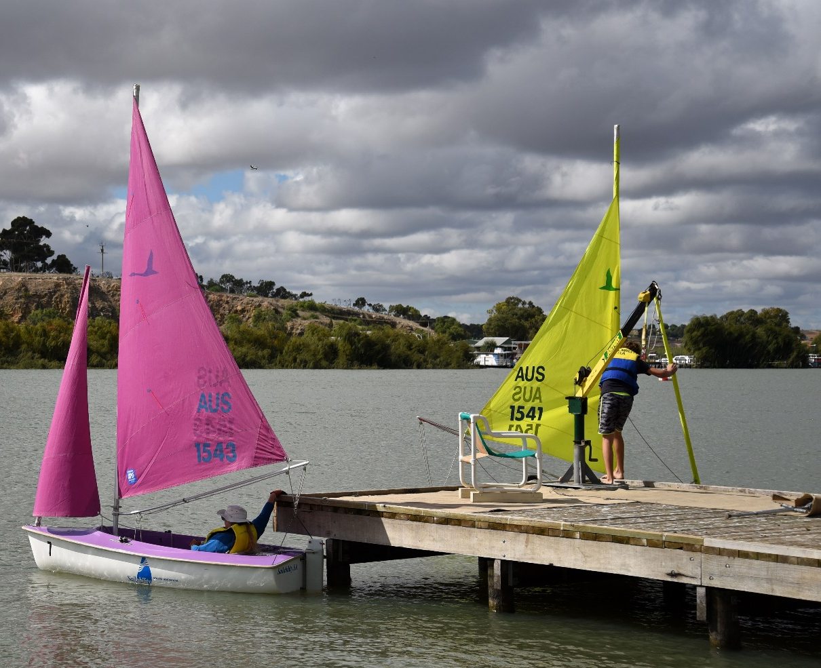
Disability Access & Inclusion Plan

Contents
1.0 About this plan 3
2.0 About disability 4
3.0 About the Rural City of Murray Bridge 5
4.0 The role of local government 6
5.0 Action Plan 7
5.1 Inclusive communities for all 8
5.2 Leadership and collaboration 10
5.3 Accessible communities 12
5.4 Learning and employment 15
6.0 Delivering our plan 17
6.1 How we will organise for success 17
6.2 Planning, delivery and review cycle 18

About this plan
This Disability Access and Inclusion Plan (DAIP) describes the actions that the Rural City of Murray Bridge will take over the next four years to facilitate equitable access to opportunities and services for people living with disability.
This means considering disability access and inclusion in Council planning and action and putting in place measures to ensure people living with disability can participate in or use Councils services, programs and facilities and that they feel welcome and engaged in community life.
The State Disability Inclusion Plan Inclusive SA was launched in November 2019 and reflects the State Government’s commitment to create an accessible and inclusive South Australia based on fairness and respect. Inclusive SA sets out state priorities and actions for the next four years under the following themes:
1. Inclusive communities for all
2. Leadership and collaboration
3. Accessible communities
4. Learning and employment.
All State Authorities including local government are required to develop a DAIP under the Disability Inclusion Act 2018 (SA). This DAIP is structured around the priority areas and actions of Inclusive SA and its development has followed the process identified in the DAIP Guidelines.
The draft DAIP was prepared using information gathered via research and targeted consultation with people with a lived experience of disability, people who care for or support people with disability and Council staff who participated at workshops and/or completed an online survey.
The draft DAIP was open for community consultation from 11 August to the 1 September 2020 and feedback was considered prior to adoption by Council.

About disability
People often think of disability in terms of limitations posed by the impaired functioning of our bodies or mind. However, the environments we create and our processes, systems, cultures and attitudes play a big part in determining the extent to which people living with disability are either enabled or disabled to live happy and productive lives.
The United Nations Convention on the Rights of Persons with Disabilities (UNCRPD) defines persons with disabilities as including those who have long-term physical, mental, intellectual or sensory impairments which interact with various barriers to hinder their full and effective participation in society on an equal basis with others.
This broader understanding recognises that disability may also be a product of the environment in which a person lives. Social, attitudinal, economic and cultural barriers can limit participation as can a person’s individual circumstances (i.e. the nature and degree of impairment, capacities and skills).

About the Rural City of Murray Bridge
This section presents Australian Bureau of Statistics (ABS) 2016 Census data, and information from the Rural City of Murray Bridge Profile id webpage (https://profile.id.com.au/murray-bridge) unless otherwise stated.
The Rural City of Murray Bridge is located in the Murraylands Region of South Australia, about 75 kilometres south-east of the Adelaide CBD. It covers an area of 183,182 hectares (1,832 km2).
People living in the Rural City of Murray Bridge are more likely to need help in their day to day lives due to disability, than for Greater Adelaide or South Australia as a whole. In 2016 6.6% of people living in the Rural City of Murray Bridge needed help, compared to 5.9% for Greater Adelaide and 6% for South Australia.
As people age, their need for assistance generally increases. The number of people aged over 60 in the Rural City of Murray Bridge is increasing and more than 50% of people aged 85 and over require assistance with core activities.
Women, children and Culturally and Linguistically Diverse (CALD) and Aboriginal and Torres Strait Islander (ATSI) communities are priority populations for the State Disability Inclusion Plan. Compared to Greater Adelaide there are a slightly larger proportions of women and children in the Rural City of Murray Bridge that need assistance with core activities. The proportions of ATSI people and people with poor proficiency in English that need assistance is lower.
12% of the population aged over 15 in the Rural City of Murray Bridge provide unpaid assistance to a person with a disability, long term illness or old age. This is comparative to the rate for South Australia (12.2%).

The role of local government
Local Government has a range of roles and responsibilities in relation to our community, including vulnerable groups and people living with disability. These roles and responsibilities differ to those of other support agencies.
Councils do not provide formal health services, schools and tertiary education and they do not make the laws. While Councils facilitate an environment where businesses are able to thrive, they do not have a primary responsibility for general economic security and employment.
Councils do play very important roles as advocates to, and partners with, State and Commonwealth government and service providers, non-government organisations (NGO’s) and the private sector to enable their communities to have access to the services they need to live full and rewarding lives.
Councils provide very important services and programs that contribute to social inclusion, health and well-being. Councils provide and manage libraries, community centres, open spaces for active recreation, parks and gardens for relaxation and social interaction.
The quality of the physical and built environment that supports accessibility for people living with disability is a key focus for the design and maintenance of public spaces and Council owned and managed buildings.
Councils are often the first point of contact for local residents and businesses, highlighting the importance of appropriate information provision and customer service and support.
Councils provide a range of avenues for people to participate in making decisions about matters that affect their lives. It is important that these methods recognise and respond to any particular barriers that might limit the ability of people living with disability to participate.
The State Government Planning Reforms are looking to create a single suite of development policies that will be applied across the state through the Planning and Design Code. The Code will set objectives for access and inclusion in developments. Councils, as the assessment authority, will play a role in ensuring that developers appropriately consider the access and inclusion within their developments.
Councils are significant employers in most communities. Their inclusive policies and practices can provide high quality working environments for their employees and act as a model for other businesses.
Councils often have strong volunteer involvement which is another important way for people living with disability to contribute to community life.
Councils’ commitment to building an inclusive, welcoming and responsive culture is also often reflected in its staff induction processes and training programs.
RCMB Strategic Plan Alignment
The Inclusive SA plan and RCMB DAIP align to the RCMB Strategic Plan 2020-2024, under the Great People and Lifestyle Objective including the following Focus Areas:
Healthy Active Communities
Our community are active, healthy and participation in recreational activities is accessible to them
All ages and cultures are celebrated, accommodated and valued
Our community is inclusive and welcoming with people of all ages, capabilities and backgrounds living harmoniously together

Action Plan
The Rural City of Murray Bridge DAIP is structured around the priority areas and actions of the Inclusive SA: State Disability Inclusion Plan and takes into consideration the areas of policy action under the National Disability Strategy 2010-2020. The DAIP reflects stakeholder and Council staff feedback resulting from the targeted consultation.
Inclusive SA themes are:
1. Inclusive communities for all
2. Leadership and collaboration
3. Accessible communities
4. Learning and employment.

Inclusive communities for all
Social inclusion is a priority for people living with disability as it affects all aspects of their lives. The contributions and rights of people living with disability should be valued and understood by everyone and that their rights promoted, upheld and protected. People living with disability should be supported to advocate for their own rights.

State priorities
Inclusive SA describes three priority themes for action under inclusive communities for all:
Priority 1: Involvement in the community
Priority 2: Improving community understanding and awareness
Priority 3: Promoting the rights of people living with disability.

What we heard
- People want to build relationships and trust with staff running services so that they feel comfortable with attending Council facilities and programs
- Increasing awareness and understanding of disability (in all its forms- it’s not always visible) in Council, the community and local businesses is important
- There is a desire for more venues, events, activities and spaces that take an inclusive approach to cater for people of diverse disabilities and ages
- Building the profile of people with a disability will build community understanding and inspire others

Our goal
People living with disability feel comfortable and welcome to participate in inclusive Council events, programs and places.

Our targets
- Guidelines for accessible and inclusive services, programs and events established
- Disability awareness and valuing training delivered to all Council staff and Elected Members

Actions
Action | Lead responsibility | Timing
Develop plain language 1-page guidelines and checklist for accessible and inclusive planning of Council and community services, programs, events and hire arrangements. Include information about access, communication, relationship building and available supports
Provide disability awareness and valuing training to all Council staff and Elected Members
Celebrate all abilities and accessible and inclusive local businesses in Council communications and local media and through International Day of People with a Disability and Access Recognition awards
Increase promotion of opportunities and activities for people with disability to participate in, including through service providers (including those for women and children), Aboriginal and Torres Strait Islander and CALD communities, and targeted communications such as establishing disability contact databases or newsletters
Develop a ‘Diversity in All Documents’ guide that encourages diverse images and text in Council documents and promotions
Encourage community and disability organisations to apply for community grants for events, activities and programs that support access and inclusion

Leadership and collaboration
People living with disability want to have a greater role in leading and contributing to local government and community decision-making. The perspectives of people living with disability should be actively sought and they should be supported to participate meaningfully in local government and community consultation and engagement activities.

State priorities
Inclusive SA describes three priority themes for action under leadership and collaboration:
Priority 4: Participation in decision-making
Priority 5: Leadership and raising profile
Priority 6: Engagement and consultation.

What we heard
- People with disability and their carers want to provide their perspectives and have more of a say in Council decisions and in the planning of events and projects
- People are not always aware when consultation is happening and want to be provided with a range of opportunities to have a say (not just online)
- People want to be listened to and trust that their input will help shape decisions

Our goal
People living with disability know about and contribute to opportunities to help shape Council places, programs and decisions

Our targets
- Access and Inclusion Advisory Group established and meet regularly
- Access and Inclusion Register established

Actions
Action | Lead responsibility | Timing
Establish an Access and Inclusion Advisory Group, made up of people with lived experience of disability (including people with disability, carers, service providers, women, children, people of Aboriginal and Torres Strait Islander and culturally and linguistically diverse backgrounds), that meets regularly to help shape Council decisions, projects and process (eg. Sturt Reserve upgrade, building audits, streetscape upgrades, event planning)
Establish and utilise an Access and Inclusion Register – a list of service providers and people living with disability who are interested in Council consultation and collaboration and being given the opportunity to act as community champions. This register will also be used to better promote events and opportunities
Develop and implement an Inclusive Community Consultation Protocol that has an all ages, abilities and backgrounds lens and includes a checklist to ensure easy compliance. Consider a “buddy” system to support people to participate in engagement
Establish and implement an Access and Inclusion Complaint Management Procedure for access and inclusion issues to ensure continuous improvement and awareness and involvement across Council
Consider the need for additional resourcing requirements to drive access and inclusion outcomes if indicated during detailed delivery planning, via a future budget allocations.

Accessible communities
The accessibility of the built environment, sport and recreation, quality services and information are key to ensuring people living with disability are included and have the opportunity to equally participate in all aspects of community life.

State priorities
Inclusive SA describes three priority themes for action under accessible communities:
Priority 7: Universal Design across South Australia
Priority 8: Accessible and available information
Priority 9: Access to services.

What we heard
- Many people living with disability do not have access to a private vehicle. Supporting affordable ways to get around is important
- Access to community and public transport is a significant local issue
- People are looking for improved cycling infrastructure and more accessible footpaths
- Current disabled permit parking is a challenge
- People want improved access to buildings, businesses and places and to be able to access information about how accessible places are
- Many people do not know what opportunities are available and want better promotion through a variety of ways, including through carers and service providers

Our goal
People living with disability can access the places they want to go and the information they need

Our targets
- Access and inclusion audit of Council buildings completed
- Accessibility map and register of the Rural City of Murray Bridge created
- Review of community transport completed
- One significant public realm or facility upgrade project that comprehensively incorporates disability access and inclusion features

Actions
Action | Lead responsibility | Timing
Create a webpage to provide information about disability access and inclusion in the City of Murray Bridge
Develop a map and directory displaying the accessibility and inclusion features of Council facilities, places and locations (eg. parking, toilets, ramps, adult change facilities, quiet spaces, SARA flatbed scanner and Clearview Plus assistive technology at Library)
Review Council’s website and employ solutions to ensure that it provides a high standard of accessibility (eg font size, easy to navigate, shows the diversity of people living with disability)
Develop an accessible protocol for Council communications, documents and signage that considers easy read documents, symbols, audio and visual aids, social media audio captions, Auslan, digital and non-digital means
Review community transport options for people with disability and advocate for accessible public transport networks
Design and complete one significant public realm or facility upgrade project that comprehensively incorporates disability access and inclusion features
Prioritise locations for access upgrades to the pedestrian and cycle network including ramps, footpath surfaces and continuity, shade, rest spots, bicycle lanes and bicycle parking, and wayfinding
Undertake an audit of Council buildings to prioritise locations for access upgrades, including improving accessibility of customer service centres, doorways, wayfinding and consideration of non-physical disability (eg. sensory/quiet spaces)
Prioritise locations for new or upgrades to accessible parking spaces so that they are fit for purpose (eg. quantity, space for car ramps and lifts, and safe building access routes)
Prioritise locations for access upgrades to public toilets, including easy to open doors and adult change facilities
Develop a universal design “check/discussion list” to support planning outcomes that improve the accessibility of developments, including entrances and parking and connection with adjacent the public realm access features
Continue to update and promote large print and audio collections, home library services and assistive technologies at the library

Learning and employment
Workforce participation is fundamental to social inclusion. It provides economic independence and choice, social connections and friendships, value, identity and belonging. People living with disability should have access to inclusive places of study, education and training that provide pathways to meaningful and inclusive employment and volunteering opportunities.

State priorities
Inclusive SA describes three priority themes for action under learning and employment:
Priority 10: Better supports within educational and training settings
Priority 11: Skill development through volunteering and support in navigating the pathway between learning and earning
Priority 12: Improved access to employment opportunities and better support within workplaces.

What we heard
- People want more opportunities for work experience and volunteering to grow their skills
- Being more flexible with job descriptions and requirements would enable more people with disability to work.
- Council can set an example by leading in socially inclusive employment and volunteering

Our goal
Council provides opportunities for people living with disability to grow and apply their skills in meaningful ways

Our targets
- Increased proportion of people with disability working, training or volunteering at Council
- Access and inclusion induction training conducted for all new Council staff and Elected Members

Actions
Action | Lead responsibility | Timing
Conduct access and inclusion induction training for all new Council staff and Elected Members (eg. online disabilityawareness.com.au)
Consult with local disability service and employment agencies and people living with disability to identify and respond to barriers to employment and volunteering at Council (eg. flexible work arrangements)
Conduct access and inclusion training for managers and supervisors to promote the opportunity and funding, and support recruitment and positive work environments for people with disability
Develop skills to support staff with disability and their supervisors requiring assistance to do their job
Collaborate with local disability service and employment agencies to place people in employment, work experience, volunteering or traineeships at Council

Delivering our plan

How we will organise for success
Rural City of Murray Bridge Council
(Elected Body)
Disability Access + Inclusion Plan
Working Group
Access + Inclusion Advisory Group
SA Department of Human Services
Stakeholders

Group | Role | Membership
SA Department of Human Services | Oversee the implementation of the Disability Inclusion Act 2018 and the State Disability Inclusion Plan.  Responsible for ensuring that Councils develop, report on and review DAIPs in accordance with the Act. | Chief Executive of the Department of Health
Rural City of Murray Bridge Council (Elected Body) | Endorse the DAIP and budget allocations for its delivery. Tracking delivery through Council’s Annual Report. | Rural City of Murray Bridge Council – ie Elected Body
Disability Access and Inclusion Working Group | Oversee the delivery, reporting and review of the DAIP.  Will meet regularly to establish and monitor work programs.  Led by the Manager Community Services. The lead will be responsible for calling, chairing and recording actions from meetings. | Key Council staff responsible for delivering actions in the DAIP.
Access and Inclusion Advisory Group | To provide an access and inclusion perspective regarding the development of Council plan, projects, programs, services and events.  Meet regularly to comment on specific Council activities in the development phase.  Coordinated by the Community Services business unit of Council | People living with disability, carers or family members, service providers. Include State Plan priority groups: women, children and people of Aboriginal and Torres Strait Islander and culturally and linguistically diverse (CALD) backgrounds
Stakeholders | To collaborate with Council in the delivery of actions such as promotion of opportunities and consultation. | Service providers and organisations representing women, children and people of Aboriginal and Torres Strait Islander and culturally and linguistically diverse (CALD) backgrounds

Planning, delivery and review cycle
DAIP actions integrated into Council strategies and Asset Management Plan and Long-Term Financial Plan
Publish the new DAIP on Council’s webpage and in the SA Government Gazette and notify the Chief Executive of the Dept. for Human Services

Every 4 years review DAIP
Every 4 years review the DAIP in consultation with the community and stakeholders

Every year plan, deliver + report

This Plan was prepared for the
Rural City of Murray Bridge by
URPS Consultants
30 July 2020

Government of South Australia (2020) Disability Access and Inclusion Plan (DAIP) Guidelines for State Authorities, https://dhs.sa.gov.au/services/disability/inclusive-sa/daips
For more detail regarding the targeted consultation undertaken that has informed the preparation of this DAIP refer to the Engagement Summary Report

