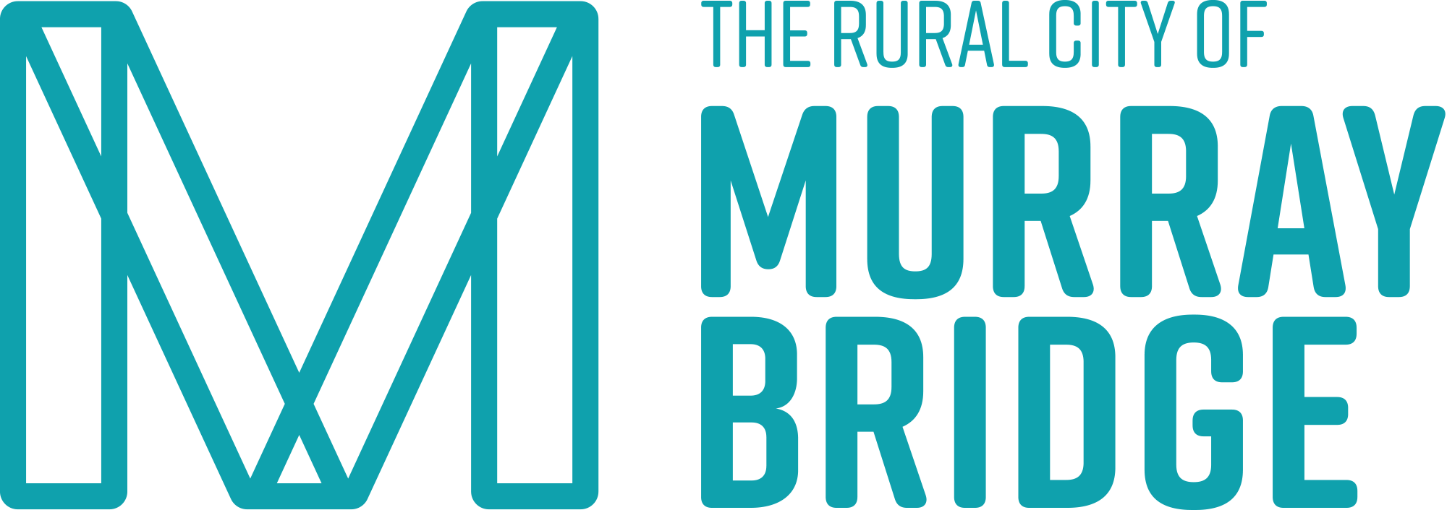

The Rural City of Murray Bridge

Disability Access and Inclusion Plan

2025 - 2029

Mayor and CEO’s Message
Council is proud to launch the Rural City of Murray Bridge Disability Access and Inclusion Plan (DAIP) 2025–2029. Over the next four years, we will work to implement the meaningful actions outlined in this plan with the goal of building a more inclusive and accessible community for all residents.
Priority initiatives will include:
- Providing access and inclusion training for all staff, volunteers and Council Members
- Ensuring Council events are inclusive and accessible
- Prioritising upgrades to Council infrastructure to meet accessibility standards
- Developing resources and materials in accessible formats
- Reviewing Council’s recruitment and interview processes to support inclusive practises
This plan has been developed through extensive consultation with the Ability Action Group (AAG), community members, disability providers, and other stakeholders, all with lived experience of disability and/or the experience of caring for or working with people living with disability. Across Council, teams have collaborated to form our internal Disability Access and Inclusion Working Group, which will oversee the delivery of actions and ensure progress is reported to both State Government and the community throughout the life of the plan.
We also acknowledge the priority groups identified through this work and the important role that intersectionality plays in the lives of people with disability. In our region, 4.5 percent of people under the age of 65 live with a profound or severe disability. Achieving genuine access and inclusion requires action at all levels of government and a shared commitment across every sector of society.
Local Government plays a critical role in shaping inclusive communities. We remain committed to listening to the voices of people living with disability and applying a disability-lens across all areas of our work, guided by the advice of the Ability Action Group.
As a Council, we must remain flexible, agile and responsive to the changing needs of our growing community. This plan reflects our ongoing commitment to listening, learning and adapting, ensuring that we continue to deliver services and initiatives that create a connected, inclusive and thriving Rural City.
We extend our sincere thanks to our community members, partners and stakeholders for their valuable contributions in shaping this plan. Your insights, experiences and participation continue to guide our shared vision for a stronger, more inclusive future for all.

Contents

Mayor and CEO’s Message 1
Acknowledgement of Country 5
Acknowledgement of Language and Terminology 5
About this Plan 6
About Disability 7
About the Rural City of Murray Bridge 8
Facts about our Region 9
Facts about Disability 9
About the Role of Local Government 11
About our continuing work from our first DAIP 14
Achievements to date 16
About the Priority Groups and Inclusion Domains 19
Priority Groups 19
Inclusion Domains 20
About accountability, performance and reporting 21
Outcomes Framework 21
Measures 21
Data limitations 22
DAIP actions 22
Domain 1: Inclusive environments and communities 22
Domain 2: Education and employment 36
Domain 3: Personal and community support 39
Domain 4: Health and wellbeing 43
Domain 5: Safety, rights and justice 46
Delivering our Disability Access and Inclusion Plan 2025-2029 48
Acknowledgements 50
Glossary and Definitions 50

Contact Details
The Rural City of Murray Bridge
2 Seventh Street
Murray Bridge SA 5253
P 08 8539 1100

This Disability Access and Inclusion Plan (DAIP) is available at The Rural City of Murray Bridge Disability Access and Inclusion.
Phone: (08) 8539 1100
After Hours: (08) 8539 1100
Email: council@murraybridge.sa.gov.au
Facebook
Instagram
YouTube
PO Box 421,
Murray Bridge SA 5253
Opening hours:
Monday to Friday 8.30 am to 4.45 pm
Closed Public Holidays

Acknowledgement of Country
We acknowledge the Ngarrindjeri people as the traditional owners of this land on which we meet and work. We respect and acknowledge their spiritual connection as the custodians of this land and that their cultural heritage beliefs are still important to the living people today.
We recognise the living culture and combined energies of the Ngarrindjeri people, our global pioneers and community members today for their unique contribution to the life of our region.

Acknowledgement of Language and Terminology
The Rural City of Murray Bridge acknowledges that the language we use can have a profound impact on the way that members of the disability community feel and how the broader community understands and responds to disability.
Findings from the Purple Orange Language Survey Report 2023-2024 highlighted that language matters. Among respondents with lived experience of disability, 31 percent preferred person-first language (e.g. "person with disability"), while 27 percent preferred identity-first language (e.g. "disabled person").
Taking into account this survey and feedback from the Department of Human Services' consultations for the State Disability Inclusion Plan 2025–2029, this plan adopts a person-centred language approach as a preferred standard.
Noting the above, it is essential to recognise and respect individual preferences. We encourage asking each person how they would like to be referred to and engaging with respectful curiosity when connecting with people with disability.
“When people are talking to someone with a disability, they worry about getting language wrong. So what do they do? They don’t talk to them and, therefore, indirectly discriminate against them.”
Dylan Alcott, AO, athlete, radio host, actor - August 28, 2022.

About this Plan
This is the second Disability Access and Inclusion Plan (DAIP) for the Rural City of Murray Bridge building on the foundations of the first plan (2020-2023). It outlines the actions Council will undertake to reaffirm our commitment to advancing meaningful and measurable improvements in accessibility and inclusion for people with disability within our community.
Under the Disability Inclusion Act 2018 (SA) (the Act), all State Authorities — including local governments — are required to develop a Disability Access and Inclusion Plan (DAIP). The Act plays a vital role in South Australia's legislative framework, aiming to promote and protect the fundamental human rights of all people with disability, regardless of age. It supports individuals with disability in reaching their full potential as equal citizens by fostering greater social connection and inclusion. The Act operates in line with the principles of the United Nations Conventions on the Rights of Persons with Disabilities (UNCRPD) and interacts with other state and national disability-rights instruments including, Australia’s Disability Strategy (ADS) 2021-2031 and the SA Autism Strategy 2024-2029. This plan also refers to the Disability Sector Strengthening Plan (DSSP) to help understand the way disability is conceptualised and experienced by First Nations people with disability.
The Act reminds us that society must do more to remove barriers for people with disability. The Disability Discrimination Act 1992 (Cth) (DDA) and the Equal Opportunity Act 1984 (SA) (EOA) set out the laws that make it illegal to discriminate against people with disability and require equal opportunities and access. These laws guide both national and state policies.
The first iteration of South Australia’s State Disability and Inclusion Plan concluded in 2023. In August 2025 the South Australian Government reaffirmed its commitment to access and inclusion with the launch of the State Disability Inclusion Plan 2025-2029: A South Australia where no one is left behind. The Rural City of Murray Bridge (RCMB) DAIP aligns with the priority areas, outcomes, and measures outlined in the State Plan and its development has been guided by the process set out in the DAIP Guidelines.
The priority areas or domains that inform the measures for our DAIP include – Inclusive Environments and Communities, Education and Employment, Personal and Community Support, Health and Wellbeing, and Safety, Rights and Justice.
The draft DAIP was prepared using information gathered via research and targeted consultation with people with a lived experience of disability, people who care for or support people with disability and Council staff.
The draft DAIP was open for community consultation from 14 October to 6 November 2025 and feedback was carefully considered prior to the finalisation of the plan.

About Disability
The UN Convention on the Rights of Persons with Disabilities (UNCRPD) defines disability as long-term physical, mental, intellectual, or sensory impairments which, in interaction with various barriers, hinder full and effective participation in society on an equal basis with others. This definition emphasises that disability is not solely an individual characteristic but also a result of societal structures.
The Royal Commission into Violence, Abuse, Neglect and Exploitation of People with Disability (Royal Commission) delivered its final report in September 2023 which was Australia’s largest inquiry into the experiences of people with disability. It identified a vision for a more inclusive Australia and highlighted that people with disability continue to be subjected to violence, abuse, neglect, exploitation, exclusion and discrimination at significantly higher rates than people without disability.
This plan is underpinned by both the Social and Human Rights Models of disability. The Social Model recognises that barriers to full participation arise not from a person’s disability, but from societal structures, attitudes, and systems. The Human Rights Model builds on this by affirming that all people are entitled to equal fundamental rights, which must be respected, protected, and fulfilled by governments at all levels, as well as by society as a whole. Together, these models form the foundation of our DAIP’s vision for a more inclusive community.
This DAIP also recognises the Life Stage approach, and that disability can affect a person at any point in their life, whether present from birth or acquired through illness, injury, accident or the ageing process. It is also important to acknowledge that disability may be understood differently across cultures and the importance of developing a Cultural Model of Inclusion which emphasises valuing diversity and fostering a sense of belonging for individuals from all cultural backgrounds. Embracing this diversity and inclusion “is derived from a belief system and worldview of humanity in which biological, physical and intellectual differences are accepted as part of the fabric of society (Avery, 2018).
“My disability exists not because I use a wheelchair, but because the broader environment isn’t accessible.”
Stella Young – Comedian, Journalist and Activist

About the Rural City of Murray Bridge
The Rural City of Murray Bridge is situated in South Australia's Murraylands region, approximately 80 kilometres south-east of the Adelaide CBD. Spanning 183,182 hectares (1,832 km²), the area includes a 65-kilometre stretch of the Murray River. The population of 21,644 comprises 50.2 percent males and 49.8 percent females, with 5.6 percent identifying as Aboriginal and/or Torres Strait Islander. The median age across the community is 43 years.

Facts about our Region
- 4.5 percent of people aged 0-64 years are living with profound or severe disability
- In 2021 8.71 percent of people needed assistance with core activities, compared with 6.66 percent in South Australia
- 1 percent of people were living with dementia in 2021, compared to 0.6 percent in Adelaide
- In 2021 21.4 percent of people were living with one long-term health condition, compared to 16.1 percent in Adelaide and 20.3 percent in South Australia
- In 2021 13.7 percent of people over 15 years provided unpaid assistance to a person with a disability, health condition or due to old age, compared with 7.9 percent in Adelaide and 13.1 percent in South Australia

Facts about Disability
- In 2022, 5.5 million (21.4 percent) Australians had disability, an increase from 4.4 million (17.7 percent) in 2018
- Indigenous Australians are 1.9 times as likely to have disability than non-indigenous Australians
- 73 percent of LGBTQ+ adults with severe disability, compared with 55 percent of LGBTQ+ adults without disability, have reported experiences of intimate partner or family violence
- 946,300 (12.1 percent) children and young people aged between 0-24 years had disability in 2022, compared to 8.3 percent in 2018
- In 2022, 52.3 percent of people aged 65 years and over had disability, compared with just 15 percent of people aged 0-64 years
- 6.9 percent of South Australian people with disability were unemployed in 2022, compared with 3 percent without disability
- Women with disability are twice as likely to experience sexual violence as women without disability
- 1 in 7 (15 percent or 345,000) people with disability aged 5–64, living in households and who leave home, do not have public transport available in their area. A further 1.1 percent (or 26,000) do not know if public transport is available in their area (ABS 2019)
- Almost two in five (38.6 percent) of carers have disability themselves
- For the first time, the 2021 National Census included Auslan as a prompt when asking what language was used at home, following unsuccessful attempts to have it included in previous Censuses. 16,242 people indicated they use Auslan at home in 2021 despite approximately 14 percent of Australians having at least one long-term hearing disorder

About the Role of Local Government
Action is needed across all levels of Government and through a shared commitment and collaboration across all sectors of society to achieve true access and inclusion. Local Government has a range of roles and responsibilities in relation to our community and these roles and responsibilities differ to those of other agencies.
Councils are not responsible for state or federal responsibilities such as education, healthcare, or major infrastructure projects and they do not make laws.
Our Community Plan 2016-2032 sets the vision for the future of our city of ‘thriving communities’. For all members of the community to thrive we will continue to advocate to, and partner with, State and Commonwealth government, service providers, non-government organisations (NGOs) and the private sector to enable community members to have access to the services that they need for full and rewarding lives.
Councils can ensure access, inclusion and community participation through,
- Accessible facilities and services ensuring that local facilities, infrastructure and public spaces, like playgrounds, are accessible
- Inclusive planning and design and involve people with disability in the planning and design of community projects and services
- Identifying and removing barriers to participation in local events, activities and decision-making processes
- Community engagement to ensure that people with disability have a voice in local decision-making
- The promotion and delivery of diverse activities and events
- Leadership and awareness through the promotion of the value of inclusion and challenging discriminatory attitudes in the community
- Offering grant programs that support organisations that provide services and programs for people with disability
- In-home support to assist people to live independently
- Advocating for better public transport and supporting community transport to help people with disability access activities and services
- Promoting inclusive employment practices and creating supportive workplaces for people with disability
- Supporting strong volunteer programs that are inclusive for those living with disability
The Disability Access and Inclusion Plan is not a standalone document and aligns with the Rural City of Murray Bridge’s Strategic Plan 2024-2028 – Growing Thriving Strong - and links strongly to aspects of Focus Area 2 Connecting People and Places and Focus Area 4 Supporting our Communities.
The DAIP also draws on other key strategic documents, including the Murraylands and Riverland Local Government Association (MRLGA) Regional Public Health and Wellbeing Plan 2022–2026, the South Australian Public Health Act 2011, and the South Australian State Public Health Plan 2019–2024. These documents recognise the critical role local governments play in public health and encourage the development of regional public health plans that foster collaboration between councils and stakeholders to improve health outcomes across communities.
The Regional Public Health and Wellbeing Plan is the second of its kind for the Murraylands and Riverland region. It is a collaborative effort between the MRLGA and its eight member councils: the Rural City of Murray Bridge, District Council of Karoonda East Murray, Southern Mallee District Council, Mid Murray Council, Coorong District Council, Renmark Paringa Council, Berri Barmera Council, and the District Council of Loxton Waikerie.
Importantly, the plan highlights that the Murraylands and Riverland region, compared to Regional South Australia as a whole, has a higher proportion of people living with a profound or severe disability, as well as a comparable percentage of residents providing unpaid care. This context reinforces the importance of inclusive planning and responsive action at the local government level.
“The vision sees South Australia’s rich diversity celebrated, community activities accessible to everyone and residents participating and having a say in community life. The vision provides an opportunity for everyone to work together at a local and State level to improve health and wellbeing in South Australia”.

South Australian State Public Health Plan 2019 – 2024.

About our continuing work from our first DAIP
A key action of Council’s initial DAIP was to “Establish an Access and Inclusion Advisory Group, consisting of people with lived experience of disability (including people with disability, carers, service providers, women, children, people of Aboriginal and Torres Strait Islander and culturally and linguistically diverse backgrounds), that meets regularly to help shape Council decisions, projects and processes.”
In response, the Ability Action Group (AAG) was established in July 2021 as a sub-committee of the Rural City of Murray Bridge’s Community Advisory Committee (CAC)—a Section 41 Committee under the Local Government Act 1999. The AAG continues to meet quarterly and plays an active role in advancing access and inclusion across the community.
As living documents, DAIPs are designed to evolve alongside the changing needs of the disability community. Central to this is the ongoing engagement of people with lived experience of disability.

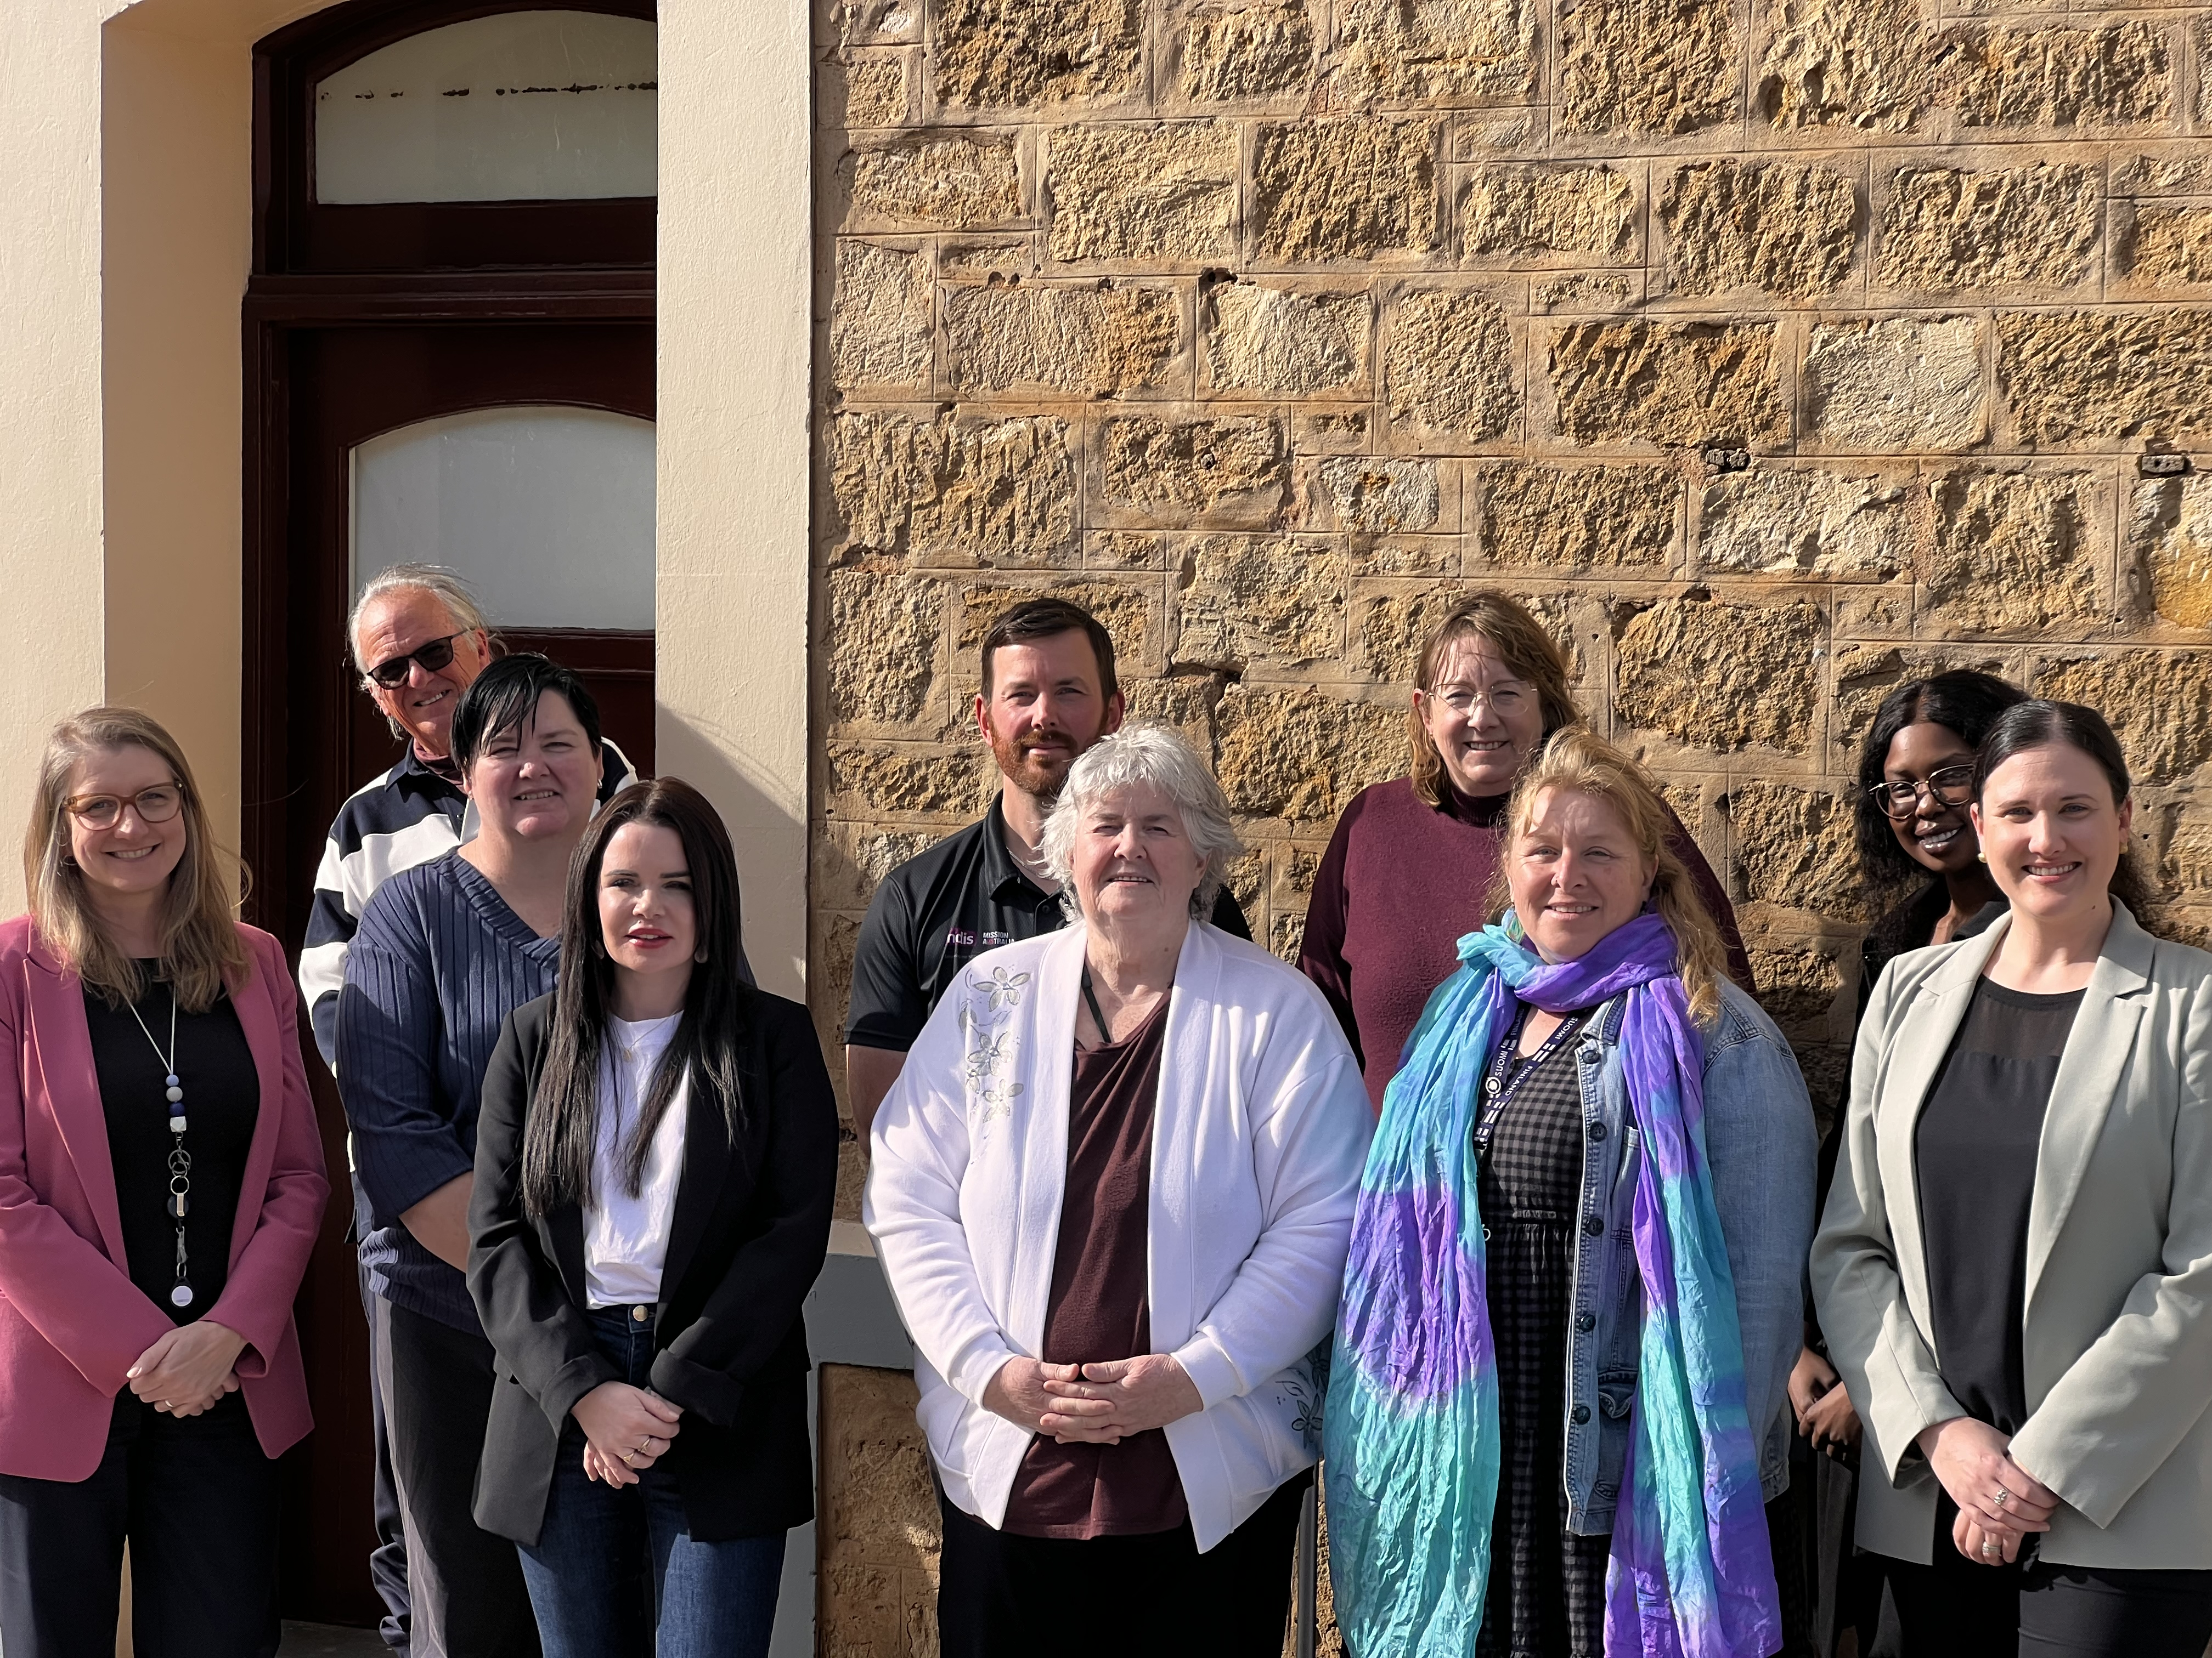
Image 1 - The Ability Action Group
L-R: Diane Humphries (RCMB Community Development Officer), Peter Crowley (AAG and CAC Member), Murrianna Reese (AAG Chair), Gabrielle Mackenzie (AAG Member), Brendan Markwick (AAG Member), Ann Kinloch (AAG Member), Heather Davis (AAG Member), Cr Lisa Courtney (AAG, CAC and Council Member), Akuot Chol (RCMB Placement Student), Ashleigh Atze (RCMB Acting Team Leader Community Development)

Achievements to date.

Universal Design
- Playground upgrades at Magpie Reserve Torrens Road and Casuarina Reserve include components of play to accommodate inclusive play.
- Bus shelter upgrade on Frances Street, Murray Bridge includes DDA compliant tactiles to assist visually impaired users.
- The Toilet Program saw Edwards Square female toilet being refurbished to accommodate wheelchair disability access and the Baden Powell toilets upgrade.
- At the end of 2024 Council had 55 accessible car parks.

Multi-media Devices and inclusive signage
Lerwin purchased the Tovertafel, or magic table, which is an innovative light projection device that brings interactive games and puzzles to life on flat surfaces and has been meticulously designed to stimulate physical, mental and social activity, catering specifically to individuals with cognitive challenges.

Meaningful Volunteering Opportunities
The Rural City of Murray Bridge continues to facilitate meaningful volunteering opportunities for people living with disability.

Celebrating all abilities and accessible and inclusive local businesses
- RCMB International Day of People with Disability Recognition Awards.
- The establishment of the Murray Bridge Wellbeing Hub. People living with disability are included as part of the five target audiences and the Hub continues to successfully deliver programs tailored to the needs of those living with disability.
- The RCMB Brinkley ReUse Centre continues to host Coffee and Music every Tuesday morning. Local community members living with disability also join in and are accompanied by their support workers to this inclusive and welcoming space.
- In October 2024 the Integrated Murraylands Physical Activity Committee (IMPAC) with the support of the RCMB hosted their first inclusive come and try sports activity for primary school aged children at the Murray Bridge Showgrounds. The SA sporting bodies represented by SANFL, Basketball, Cricket and Tennis were all in attendance.

Community Grants to Support Access and Inclusion
- Bridge City Church ‘Ablution Solution’ – accessible shower, toilet and laundry.
- All Abilities Festival – hosted annually by Livit Disability Support (previously Community Living Australia) at the Murray Bridge Swimming Centre.
- The Wellington Progress Association - unisex/ accessible toilet option.

The Murray Bridge Library
The library continues to update and promote large print, audio collections and assistive technologies. The Memory Hub continues to grow and offers resources for those living with dementia.

Inclusive Events
The events team ensured the following at all outdoor events during 2024.
- Free entry.
- Located in parks and reserves that have even pathways, clear entry points, well sign posted.
- Provide additional access parking and advertise this in pre-event information.
- Provide accessible toilets.
- For larger events held in smaller reserves, quiet spaces are provided.
Advertising is on digital platforms including screens around the city, website, social media.

Employment
The RCMB volunteers program continues to support volunteers to apply for vacancies which are recruited for both internally and externally by Council. Council continues its employment partnerships with local disability employment providers including Community Bridging Services (CBS) and employs Andrew Watkins in the Community Development and Events teams.
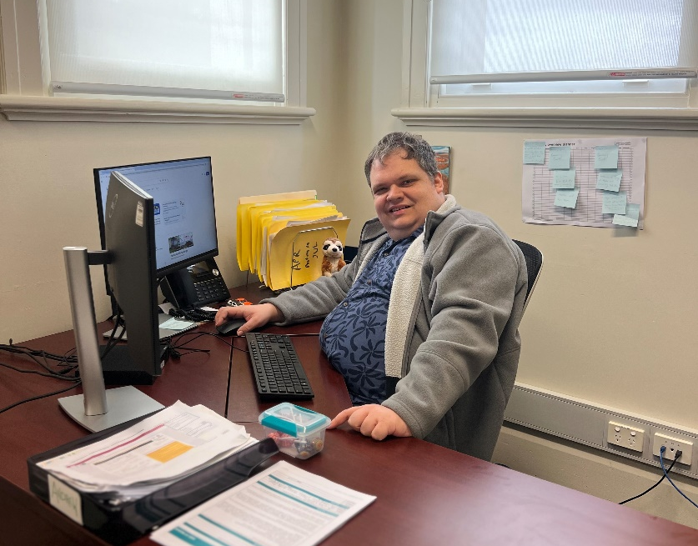
Image 2 Andrew Watkins

About the Priority Groups and Inclusion Domains
The Rural City’s DAIP is structured around the South Australian Government’s Priority Groups and Inclusion Domains. This approach reflects an understanding of the intersectionality of disability—that disability does not exist in isolation but often intersects with other social identities such as gender, sexuality, race, age, regionality, socioeconomic status and more.
Intersectionality recognises that individuals with disability may face unique and compounded forms of discrimination and barriers resulting from the interplay of these overlapping identities.
The Disability Inclusion Act 2018 (SA) highlights seven priority groups, which State authorities must tailor policies, programs and services to meet their diverse needs to ensure genuine access and inclusion.

Priority Groups
- Aboriginal people with disability
- Culturally and linguistically diverse (CALD) people with disability
- Women with disability
- Children with disability
- LGBTIQA+ people with disability
- People with significant intellectual disability or who have high levels of vulnerability due to disability
- People with disability who live in regional areas
In addition to these seven legislated priority groups, this DAIP also acknowledges the compounding barriers that are faced by older people with disability and carers, and whilst not a priority group, this plan aims to apply an ageing and carer-inclusive lens across all population groups, domains and actions.

Inclusion Domains
These priority areas or Domains were created through the emerging themes from the statewide consultation process conducted by State Government during the development of the State Plan.
Domain 1: Inclusive Environments and Communities
All people with disability can participate as equal citizens and feel connected to their communities.
Domain 2: Education and Employment
All people with disability benefit from inclusive educational experiences, equitable employment opportunities and financial security.
Domain 3: Personal and Community Support
All people with disability can access quality, tailored personal and community supports addressing their individual needs.
Domain 4: Health and Wellbeing
All people with disability can attain the highest possible health and wellbeing outcomes throughout their lives.
Domain 5: Safety, Rights and Justice
All people with disability feel safe, have their rights upheld and have full and equal protection before the law.
The Inclusion Domains represent key areas of focus and priority for the next four years. While some domains will require immediate action, others will be addressed through a staged approach—building on progress made under the previous DAIP. This flexible framework also allows for the incorporation of emerging initiatives and reforms at both the state and national levels.

About accountability, performance and reporting
The Act makes it clear that the State Plan must specify measurable outcomes for each Domain. Achieving these outcomes requires a shared commitment across all levels of government. To maintain accountability Council is required to report annually on the actions taken through the DAIP to the DHS Chief Executive. This information is then consolidated and included in the State Plan annual report, which is submitted to the Minister for Human Services and tabled in Parliament. This regular reporting helps track progress, identify what’s working and highlight areas that need more attention.
The State Plan explains what we want to achieve and why we want to do it. DAIPs detail how we will achieve it and when we will do it. Annual reporting will show how we are going.

Outcomes Framework
The Outcomes Framework outlines 27 priority areas that the disability community informed State Government are important. For each priority area there is an outcome, these are what State Government is aiming to achieve. The 18 measures assigned to Local Government by the State Government are reflected in the RCMB DAIP and will be reported against annually. Council has also added an additional measure in Domain 4: Health and Wellbeing. Council does not have a requirement to report against all priority areas in each Domain.
This Framework provides a long-term, sustainable approach that promotes transparency, tracks change over time, and helps assess the impact of access to supports, services and overall inclusion for people with disability in our community.

Measures
Outcomes are assessed using both proportions and total numbers (quantitative data):
- Proportions indicate the percentage of a group with a specific characteristic.
- Total numbers refer to the actual count of individuals or instances.

Each reporting stage will also include qualitative data, such as personal stories and lived experiences, to better understand not just what is happening, but how people are experiencing it.
Data limitations
There are some limitations to be aware of when interpreting the data:
- Disability disclosure is not mandatory
- Measuring outcomes for people with disability can be complex
- Disaggregated data or data that has been broken down into smaller, more specific categories or sub-groups i.e. age or gender, is not always available

DAIP actions

Domain 1: Inclusive environments and communities

Outcome Statement
A South Australia where all people with disability can participate as equal citizens and feel connected to their communities.

Objective
To influence community attitudes to remove discrimination and build a South Australian community that values difference and respects the contributions people with disability make to our communities. This includes ensuring the community itself is fully accessible.

Priority Areas for Domain 1
- Active participation
- Inclusive communities and attitudes
- Universal Design
- Accessible facilities
- Communications and information
- Transportation
- Collaboration, consultation and innovation
- Housing

Priority Area 1: Active participation

Outcome
People with disability are active participants in accessible and inclusive communities.

State Plan Measure 1.1.2
The number of inclusive and accessible events, both internal and external, with 50+ people following best practice event management principles. For example, the Accessible and Inclusive Community Events Toolkit.

Action
Further development, in consultation with the Ability Action Group (AAG), and endorsement by Council of the following documents which include how to implement best practice event management principles for all council events.
- Event Planning Guide
- Accessible Events Guide
- On Day Accessible Events Checklist

Timeframe
December 2026

Responsibility
Events Team

Data Source
Community Advisory Committee and Council minutes once endorsed

Action
Ensure all council led- events for 50 or more people implement best practice event management principles and regularly evaluate and enhance event inclusion and accessibility for people with disability.

Timeframe
Ongoing

Responsibility
Events Team and Internal DAIP Working Group

Data Source
Event evaluation surveys and event booking application

Priority Area 2: Inclusive communities and attitudes

Outcome
People with disability are respected and included in their communities, where inclusive attitudes and behaviours are widely demonstrated.

State Plan Measure 1.2.1
The number of initiatives undertaken to promote disability inclusion and improve community attitudes towards people with disability in the community, including:
- The number of staff and volunteers participating in disability awareness training, including Universal Design.

Action
Review RCMB’s induction process to ensure staff and volunteer disability awareness training is included as part of the induction modules at the commencement of employment. Utilising Skytrust for staff and Better Impact for volunteers.

Timeframe
December 2026

Responsibility
People and Culture and People and Payroll

Data Source
Staff training log

Action
Conduct disability awareness training for all Council Members.

Timeframe
December 2027

Responsibility
OCEO

Data Source
Council Member’s training register

Action
Conduct disability awareness training for all existing Council staff members and for new staff upon commencement.

Timeframe
Ongoing

Responsibility
People and Culture and People and Payroll

Data Source
Staff training log

State Plan Measure 1.2.1
The number of initiatives undertaken to promote disability inclusion and improve community attitudes towards people with disability in the community, including:
- The number of workplace initiatives promoting disability inclusion.

Action
Create a log to record the number of initiatives, including workplace initiatives, such as intranet posts, social media, awareness campaigns that promote disability access and inclusion and improve community attitudes.

Timeframe
Ongoing

Responsibility
Internal DAIP Working Group – lead by Community Development

Data Source
Log to record from meeting minutes

Action
Consult with the Ability Action Group and Council Members regarding the development of an acknowledgement that incorporates the inclusion of all priority groups and acknowledges the role of intersectionality, to be used at appropriate meetings and as signage when entering Council buildings.

Timeframe
Ongoing

Responsibility
DAIP Internal Working Group in collaboration with the Ability Action Group

Data Source
Number of buildings and meetings that incorporate this

State Plan Measure 1.2.3
The number of actions embedded in our DAIP working towards Closing the Gap targets.

Action
Facilitate genuine engagement with Aboriginal and Torres Strait Islander peoples living with disability, along with their families and carers, through inclusion on the Reconciliation Action Plan (RAP) Working Group (external). Ensure Disability Access and Inclusion Plan (DAIP) priorities are regularly tabled and discussed through this forum. This will provide strengthened representation and voice for Aboriginal and Torres Strait Islander people with disability in Council decision-making processes, contributing to culturally safe, inclusive practices.

Timeframe
Ongoing

Responsibility
Community Development

Data Source
Minutes from the Reconciliation Action Plan (RAP) Working Group (external).
This action aligns with Priority Reform One of the National Agreement on Closing the Gap, Formal Partnerships and Shared Decision-Making, which promotes genuine engagement with Aboriginal and Torres Strait Islander peoples

Action
Through representation on Reconciliation Action Plan (RAP) Working Group (external), members/family members/carers of people living with disability on this group will be invited to sit on the Ability Action Group.

Timeframe
Ongoing

Responsibility
Community Development

Data Source
Minutes from the Ability Action Group
This action aligns with Priority Reform One of the National Agreement on Closing the Gap, Formal Partnerships and Shared Decision-Making, which promotes genuine engagement with Aboriginal and Torres Strait Islander peoples

Action
Aboriginal and Torres Strait Islander children living with disability have access to high quality culturally appropriate Library programs that encourage and support them to thrive in their early years.

Timeframe
Ongoing

Responsibility
Library Team

Data Source
Program evaluations
Alignment: Closing the Gap Target 3: Aboriginal and Torres Strait Islander children are engaged in high quality, culturally appropriate early childhood education in their early years. Target 4: Aboriginal and Torres Strait Islander children thrive in their early years.
Priority Area 3: Universal Design

Outcome
Everyone in South Australia can access and enjoy inclusive and accessible natural and built environments.

State Plan Measure 1.3.2
The number of public-facing council buildings, spaces, play spaces and infrastructure that are modified to improve accessibility. For example, by adding signage or widening doors.

Action
Undertake an audit of Council infrastructure, in consultation with the Ability Action Group, to prioritise locations for access upgrades. This will include improvements to customer service centres, doorways, and wayfinding, as well as consideration of sensory and quiet spaces. Ensure that a disability access and inclusion lens is embedded within the current Asset Management Plan.

Timeframe
December 2026

Responsibility
Infrastructure and Environment

Data Source
Audit log

Action
Record and report on accessibility modifications to public-facing council buildings/entry, including details such as the type of modification (e.g., signage installation, door widening).

Timeframe
Ongoing

Responsibility
Infrastructure and Environment

Data Source
Action log

State Plan Measure 1.3.2
The number of new council developments that incorporate Universal Design.

Action
Record and report on new council-built developments, including how Universal Design principles were incorporated.

Timeframe
Ongoing

Responsibility
Infrastructure and Environment

Data Source
Action log

Action
Deliver Universal Design training for staff involved in the design, implementation, and delivery of Council developments and projects.

Timeframe
Ongoing

Responsibility
People and Culture, People and Payroll and Infrastructure and Environment

Data Source
Training log

State Plan Measure 1.3.3
The number of parks, reserves, beaches and playgrounds (within these areas) that are built or modified to improve accessibility.

Action
Undertake an audit of Council’s open recreational spaces to identify and prioritise locations requiring modifications to improve accessibility.

Timeframe
Ongoing

Responsibility
Infrastructure and Environment

Data Source
Action log

Action
Record and report on accessibility modifications implemented in existing Council open recreational spaces, as well as those incorporated into the design and development of new projects.

Timeframe
Ongoing

Responsibility
Infrastructure and Environment

Data Source:
Action log

Priority Area 4: Accessible facilities

Outcome
People with disability can access public toilet facilities that meet their needs when out in the community.

State Plan Measure 1.4.1
The number of public council owned toilet facilities across the council area that meet accessibility standards and/or a designated Changing Places facility.

Action
Ensure that the development of the new RCMB Public Toilet Strategy incorporates the requirement to meet accessibility standards and investigates the implementation of Changing Places facilities.

Timeframe
December 2026

Responsibility
Infrastructure and Environment

Data Source
Public Toilet Strategy

Action
Record how many council owned toilets within the council area meet accessibility standards or are a designated changing places facility.

Timeframe
Ongoing

Responsibility
Infrastructure and Environment

Data Source
Action log

Action
Ensure that accessibility standards for the Murray Bridge Swimming Centre facilities are included in the development of the Asset Management Plan.

Timeframe
December 2026

Responsibility
Infrastructure and Environment

Data Source
Asset Management Plan

Action
Scope and explore funding opportunities for the development of a Changing Places facility at the Murray Bridge Swimming Centre.

Timeframe
December 2027

Responsibility
City Assets with support of the Ability Action Group

Data Source
AAG Minutes
Priority Area 5: Communications and Information

Outcome
People with disability can find the information they need in the format(s) they need it in.

State Plan Measure 1.5.1
The number of resources or materials that have been developed in accessible formats. For example, websites that meet Web Content Accessibility Guidelines (WCAG) 2.2 level AA accessibility standard or above, Auslan translations and Easy Read documents.

Action
The number of strategic public documents and internal documents created in Easy Read, plain language, video or another format.

Timeframe
Ongoing

Responsibility
Communications Team

Data Source
Action Log

Action
Explore opportunities for key staff to undertake Easy Read training

Timeframe
December 2026

Responsibility
Community Development and Communications Team

Data Source
Training log

Action
Develop a ‘Diversity in All Documents’ guide that encourages diverse images and text in Council documents and promotions.

Timeframe
December 2026

Responsibility
Communications Team

Data Source
Diversity in All Documents guide

Priority Area 7: Collaboration, consultation and innovation

Outcome
People with disability are actively involved in government decisions that affect their lives.

Measure - State Plan Measure 1.7.1
The number of public consultations that included and sought input from people with disability.

Action
Ensure public consultations include and seek input from priority groups.

Timeframe
Ongoing

Responsibility
Communications Team

Data Source
Action Log

Action
The number of public consultations and projects that have engaged with the Ability Action Group during the development process.

Timeframe
Ongoing

Responsibility
Internal DAIP Working Group

Data Source
Action log from stakeholder list which will include the AAG

Action
Ensure that the review of the RCMB’s Engagement Policy includes an inclusive community consultation protocol through collaboration with the Ability Action Group. This also needs to consider a priority group lens and consider a “buddy’ system to support people to participate in engagement.

Timeframe
December 2027

Responsibility
Communications Team with support from the Ability Action Group

Data Source
RCMB Engagement Policy

State Plan Measure 1.7.2
The number of people with disability, including parents and carers, serving on committees and working groups.
Note: Committees are formal groups set up by councils to provide strategic advice or make decisions on disability inclusion.
Working groups are task-focused teams that address specific issues or actions supporting disability inclusion.

Action
Facilitate genuine engagement with committee and working group members across all areas of Council, encouraging the safe disclosure of disability in a supported environment. This will enable meaningful collaboration and ensure the provision of strategic advice that strengthens Council’s commitment to disability access and inclusion for all priority groups.

Timeframe
Ongoing

Responsibility
DAIP Internal Working Group

Data Source
Targeted Survey

Domain 2: Education and Employment

Outcome Statement
A South Australia where all people with disability benefit from inclusive educational experiences, equitable employment opportunities and financial security.

Objective
To ensure equal opportunity to learning and earning is achieved by addressing the barriers and obstacles people with disability of all ages continue to face at all levels of the education and employment experience.

Priority Areas for Domain 2
- Targeted knowledge, understanding and support
- Supports and resources for children and young people
- Targeted transitional supports
- Access to employment opportunities
- Inclusive working environments
- Data and reporting

Priority Area 3: Targeted transitional supports

Outcome
People with disability have supportive environments to learn, grow, and transition throughout their life.

State Plan Measure 2.3.5
The number of initiatives taken to encourage people with disability to volunteer.

Action
Create and maintain a log to record the number of initiatives - specific volunteer supervisor training, promotion of inclusive volunteer programs and interview processes, intranet posts, social media activity, and awareness campaigns—that promote disability access and inclusion and encourage people with disability to volunteer ensuring a priority group lens.

Timeframe
Ongoing

Responsibility
Volunteer Management Team

Data Source
Action Log

Priority Area 4: Access to employment opportunities

Outcome
People with disability have opportunities to achieve, develop and succeed in their chosen fields.

State Plan Measure 2.4.3
The number of organisational changes adopted to improve inclusive recruitment for people with disability. For example, tailoring roles to fit individuals and employer incentives.

Action
Deliver targeted training specifically for staff within the People and Culture team.

Timeframe
June 2026

Responsibility
People and Culture and People and Payroll

Data Source
HR Training Log

Action
Investigate and review current Council position descriptions (staff) and role statements (volunteers), in collaboration with the Ability Action Group, for both staff and volunteers to strengthen access and inclusion—for example, by using plain language, tailoring roles, incorporating inclusive terminology, and exploring alternative application methods such as video submissions.

Timeframe
December 2028

Responsibility
People and Culture, People and Payroll and Volunteer Management Team

Data Source
Action Log

Action
Investigate and review Council’s interview processes, in collaboration with the Ability Action Group, for both staff and volunteers to ensure that any required adaptations or supports are identified and offered prior to interview.

Timeframe
December 2026

Responsibility
People and Culture and People and Payroll

Data Source
Action Log

Priority Area 5: Inclusive working environments

Outcome
People with disability have access to supportive places to earn.

State Plan Measure 2.5.1
The number of workplace practices implemented to support people with disability to have equal opportunities for growth and success, including support to remain in employment. For example, outcome-based employment, flexible work arrangements, workplace adjustments and mentoring programs

Action
Review Council’s recruitment policy in collaboration with the Ability Action Group, to ensure it supports people with disability to have equal opportunities for employment, growth, and success, including the provision of supports to remain in ongoing employment.

Timeframe
December 2027

Responsibility
People and Culture and People and Payroll

Data Source
Recruitment Policy

Action
Continue to create and maintain partnerships with local job providers specialising in employment and work experience opportunities for people with disability, including outcome-based employment, flexible work arrangements, workplace adjustments, and mentoring programs.

Timeframe
Ongoing

Responsibility
People and Culture, People and Payroll, Community Development and Growth and Economic Development

Data Source
Action Log

Domain 3: Personal and Community Support

Outcome Statement
A South Australia where people with disability can access quality, tailored personal and community supports addressing their individual needs

Objective
To build a service system in South Australia that takes a person-centred approach that recognises the contributions and potential of all people with disability.

Priority Areas for Domain 3
- Accessibility
- Advocacy and supports
- Information sharing
- Family and carer support
- Programs

Priority Area 1: Accessibility

Outcome
People with disability can easily access community supports and services.

State Plan Measure 3.1.1
The number of council initiatives and improvements made to connect people with disability to community supports and services wherever they present. For example, referral hubs, mobile outreach, online information platforms, frontline worker training, and partnerships with community organisations.

Action
Establish and strengthen collaboration and partnerships with service providers and community organisations to improve access to supports and services for people with disability.

Timeframe
Ongoing

Responsibility
Internal DAIP Working Group

Data Source
Action Log

Action
Development of the Council website Access and Inclusion page including providing resources and connections to other services for people living with disability.

Timeframe
Ongoing

Responsibility
Communications Team and Community Development

Data Source
Council website

Priority Area 3: Information Sharing

Outcome
People with disability receive more coordinated and effective support when services work together and share information.

State Plan Measure 3.3.1
The number of inter-agency meetings and initiatives to support the implementation of the State Plan and our DAIP.

Action
Participate in (Local Government Access and Inclusion Network) LGAIN and (Community of Practice) COP meetings and with external disability service providers.

Timeframe
Ongoing

Responsibility
Community Development

Data Source
Meeting minutes

Priority Area 5: Programs
Outcome
Government-funded programs and services include disability-specific provisions to enable full and equal participation.

State Plan Measure 3.5.1
The number of council grants and funding amount distributed to enhance disability inclusion.

Action
Distribute grants and funding to initiatives that enhance disability inclusion, and collect reporting through detailing recipients, funding amounts, and purposes.

Timeframe
Ongoing

Responsibility
Community Development, Growth and Economic Development and Sport and Recreation Teams

Data Source
Smarty Grants

Action
Review Council’s grant application process to ensure it is accessible and inclusive and explore ways to assess how applications address the needs of priority groups.

Timeframe
December 2026

Responsibility
Community Development, Growth and Economic Development and Sport and Recreation Teams

Data Source
Smarty Grants

Domain 4: Health and Wellbeing

Outcome Statement
A South Australia where all people with disability can attain the highest possible health and wellbeing outcomes throughout their lives.

Objective
To have a well-connected health and mental health sector that is easy to access, navigate and interact with for all people with disability.

Priority Areas for Domain 4
- Inclusive infrastructure
- Targeted knowledge, understanding and support
- Supports and interventions

Additional Council Measure
The number of Council initiatives and strategies aimed at ensuring that people living with disability can achieve the highest possible health and wellbeing outcomes throughout their lives.

Action
The Murraylands Regional Local Government Association (MRLGA) Regional Public Health and Wellbeing Plan to be developed in plain text and Easy Read format.

Timeframe
December 2027

Responsibility
Community Development and Communications Team

Data Source
MRLGA Regional Public Health and Wellbeing Plan in Easy Read

Action
Council will actively advocate for equitable health services for people living with disability, ensuring these services are inclusive and responsive to the diverse experiences and intersectional needs of the disability community, both regionally and with the State Government.

Timeframe
Ongoing

Responsibility
Internal DAIP Working Group

Data Source
Action Log
Action
Council will actively advocate for accessible public transport services for people living within the Rural City and surrounding areas. This advocacy will aim to ensure equitable access to services that support physical, emotional, intellectual, social, spiritual, and occupational wellbeing, both across the region and in partnership with the State Government.
Timeframe
Ongoing
Responsibility
Internal DAIP Working Group
Data Source
Action Log

Action
The development of a Council Wellbeing Strategy that promotes access and inclusion for all community members and is responsive to the intersectionality and diversity of disability with focus on the priority groups. The strategy will also be developed in plain text and Easy Read formats.

Timeframe
June 2027

Responsibility
Community Development and Growth and Economic Development

Data Source
Endorsement of the RCMB Wellbeing Strategy

Domain 5: Safety, rights and justice

Outcome Statement
A South Australia where all people with disability feel safe, have their rights upheld and have full and equal protection before the law.

Objective
To improve the safety and overall experience of people with disability coming into contact with our emergency services, criminal justice and civil law systems.

Priority Areas for Domain 5
- Targeted knowledge, understanding and support
- Responding to emergencies
- Support and navigating the justice system
- Consultation and collaboration
- Safeguarding

Priority Area 2: Responding to Emergencies

Outcome
People with disability are kept safe during emergencies, with their needs planned for and prioritised.

State Plan Measure 5.2.1
The number of emergency response resources and systems developed for people with disability, including the Person-Centred Emergency Preparedness (P-CEP) approach.

Action
Council will continue to engage in conversation with State Government agencies around preparedness to support those in the community living with disability in the event of an emergency.

Timeframe
Ongoing

Responsibility
OCEO through Zone Emergency Management Committee

Data Source
Meeting minutes

Action
Council’s Emergency Management Information website page to be reviewed regularly for access and inclusion and will provide links to external providers that may assist during emergencies. Council will consider the development of the Community Emergency Management Plan in accessible formats.

Timeframe
Ongoing

Responsibility
OCEO
Infrastructure and Environment
Communications Team

Data Source
Emergency Management Information website page

Delivering our Disability Access and Inclusion Plan 2025-2029
How we will organise for successful delivery.
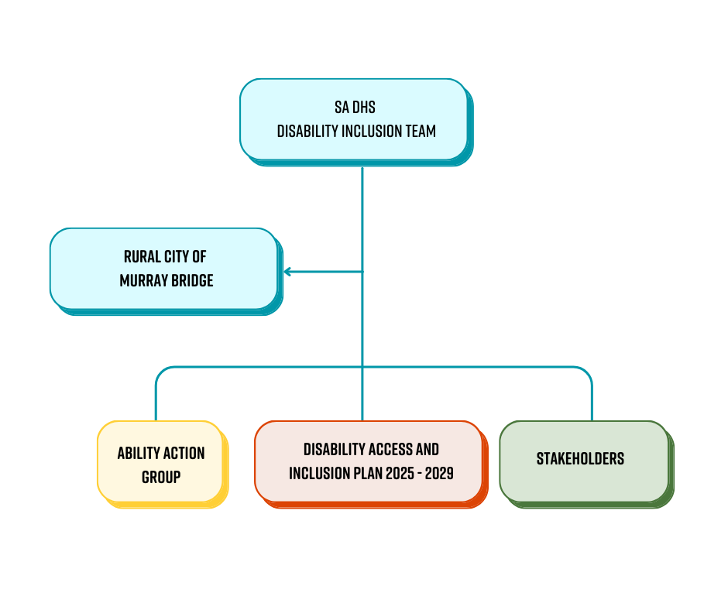
Figure 1 - Flow chart on the delivery of the Disability Access and Inclusion Plan 2025 - 2029

SA DHS Disability Inclusion Team

Role
Oversea the implementation of the Disability Inclusion Act 2018 and the State Disability Inclusion Plan 2025-2029.

Membership
Chief Executive of the Department of Health.

Rural City of Murray Bridge Council (Elected Body)

Role
Adopt the RCMB Disability Access and Inclusion Plan 2025 – 2029 and budget allocations for delivery. Tracking delivery through Council’s Annual Report.

Membership
Rural City of Murray Bridge Council – Elected Body.

Disability Access and Inclusion Working Group (internal)

Role
Oversea the delivery, reporting and review of the DAIP. Meet regularly to establish and monitor work programs. Lead by the Community Development team.

Membership
Key Council staff responsible for delivering actions in the DAIP.

Ability Action Group (AAG)

Role
Provide an access and inclusion lens regarding the development of Council plans, projects, programs, services and events. Quarterly meetings coordinated by the RCMB Community Development team.

Membership
People with lived experience of disability (including people with disability, carers, service providers, women, children, LGBTIQA+ people, people of Aboriginal and Torres Strait Islander and culturally and linguistically diverse backgrounds).

Stakeholders

Role
To collaborate with Council in the delivery of actions such as promotion of opportunities and consultation.

Membership
Providers, organisations and community members representing women, children, LGBTIQA+ people, people of Aboriginal and Torres Strait Islander and culturally and linguistically diverse backgrounds.

Acknowledgements
The Rural City of Murray Bridge would like to acknowledge the following individuals, groups and organisations who have contributed to the development and implementation of this Disability Access and Inclusion Plan.
The Ability Action Group (AAG)
The RCMB Internal DAIP Working Group
The Murraylands Disability Alliance Group
The RCMB Community Advisory Committee (CAC)
The RCMB Council Members and Executive Leadership Team
Genuine Support Services Australia
Livit Disability Support
The Murray Bridge High School Inclusive Education Centre Leadership Team
Equality Life Disability Support Service

Glossary and Definitions

Accessibility
The extent to which people with disability can access information, spaces, products and services.

Action
Practical steps implemented and monitored to ensure progress towards achieving outcomes.

Advocacy
Promoting, protecting, and defending the human rights of people with disability by speaking out, providing support services, and helping individuals understand their rights

Australia’s Disability Strategy (ADS)
A national plan for inclusion, providing an overarching approach for government to meet obligations under the United Nations Convention on the Rights of Persons with Disabilities.

Best Practice
A method or technique widely recognised as superior to alternatives, either because it achieves better results or because it has become the accepted standard approach.

Built environments
Artificial structures, features, and facilities viewed collectively as an environment in which people live and work.

Civil Law
A branch of law that addresses disputes between individuals, groups, or organisations, covering areas such as contracts, property, family law, and personal injury.

Closing the Gap
A government strategy and national agreement aimed at improving life outcomes for Aboriginal peoples.

Disability Access and Inclusion Plan (DAIP)
A Disability Access and Inclusion Plan (DAIP) is a plan developed by state government agencies and local councils to improve access and inclusion for people with disability. Each DAIP is tailored to the specific context of the organisation and their community, outlining practical actions to remove barriers, promote participation, and support the goals of the State Plan.
Department of Human Services
The Department of Human Services (DHS) is a South Australian Government agency responsible for delivering strategies, programs, and services that enhance the wellbeing, safety, and inclusion of South Australians, with a focus on those who are vulnerable or disadvantaged.

Disability Discrimination Act (DDA)
The Disability Discrimination Act 1992 (Cth) is a federal law in Australia that protects individuals from discrimination based on disability in various aspects of public life, including employment, education, access to goods and services, housing, and public spaces.

Disability Inclusion Act 2018 (SA) (The Act)
A South Australian law that drives efforts to improve access and inclusion for people with disability. It requires the development of the State Disability Inclusion Plan (State Plan) and local Disability Access and Inclusion Plans, and it promotes choice, control, and the removal of barriers.

Disability Sector Strengthening Plan (DSSP)
The Disability Sector Strengthening Plan outlines high-level priorities and actions at a national level to build the community-controlled disability sector. All parties, through the Joint Council on Closing the Gap, agreed to this plan in-principle in August 2022.

Disaggregated data
Information that is divided into smaller groups to highlight differences, such as by age, gender, cultural background, or location.

Domains
Key areas of the State Plan where we will be taking action to make improvements. For example, Domain 1: Inclusive Environments and Communities

Equal Opportunity Act (EOA)
The Equal Opportunity Act 1984 (SA) is a South Australian law that promotes fairness and prevents discrimination in areas like work, education, and services based on attributes such as race, gender, disability, and age.

Inclusion
The intentional, ongoing effort to ensure that all people can fully participate in all aspects of life.

Intersectionality
The interconnected nature of social categories such as race, class, gender, sexuality and disability, which overlap to create interdependent systems of discrimination or disadvantage for individuals or groups.

LGBTIQA+
LGBTIQA+ stands for Lesbian, Gay, Bisexual, Transgender, Intersex, Queer or Questioning, Asexual, Aromantic, or Agender and other identities, with the "+" sign representing the diverse range of sexual orientations and gender identities not captured by the acronym's letters.

Lived experience
The personal knowledge that a person gains from direct, first-hand involvement with disability.

Local councils
A system of government in South Australia under which elected local government bodies (councils) are constituted under the Local Government Act 1999 (SA).

Measures
Measurable activity designed to achieve outcomes.

Murraylands and Riverland Local Government Association (MRLGA) Regional Public Health and Wellbeing Plan 2022–2026
The Rural City of Murray Bridge has joined forces with the other 7 Councils in the Murraylands and Riverlands region to develop the Murraylands and Riverland Local Government Association Regional Public Health and Wellbeing Plan. This plan identifies key partnerships with various agencies.

Outcomes
The desired result or goals that represent the intended positive changes because of the action taken.

Priority Areas
Specific areas of focus that require targeted action.

Qualitative Data
Non-numerical, descriptive information that captures qualities, characteristics, and subjective experiences, such as words, concepts, feelings, or observations.

Quantitative Data
Information that can be counted or measured numerically, answering questions like "how many," "how much," or "how often".

Rural City of Murray Bridge’s Strategic Plan 2024-2028 – Growing Thriving Strong
This plan outlines the priorities for the next four years, identifying objectives, programs, and projects under each Strategic Focus Area that Council intends to deliver.

Safeguarding
The process of protecting people's health, wellbeing, and human rights to ensure they are safe from harm, abuse, and neglect.

South Australian Public Health Act 2011
An Act to promote and to provide for the protection of the health of the public of South Australia and to reduce the incidence of preventable illness, injury and disability; and for other purposes.

South Australian State Public Health Plan 2019–2024
This plan establishes the vision for a healthy, liveable and connected community for all South Australians.

State authority
As defined in the Disability Inclusion Act 2018: an administrative unit, agency, or council (within the meaning of the Public Sector Act 2009 (SA), or a local council established under the Local Government Act 1999 (SA).

UNCRPD
United Nations Convention on the Rights of Persons with Disabilities is a human rights treaty that aims to change attitudes and approaches to people living with disability. It reaffirms that all people living with disability must enjoy human rights and fundamental freedoms.

Universal Design
Universal Design involves creating facilities, built environs, products and services that can be used by people of all abilities to the greatest extent possible without adaptations.

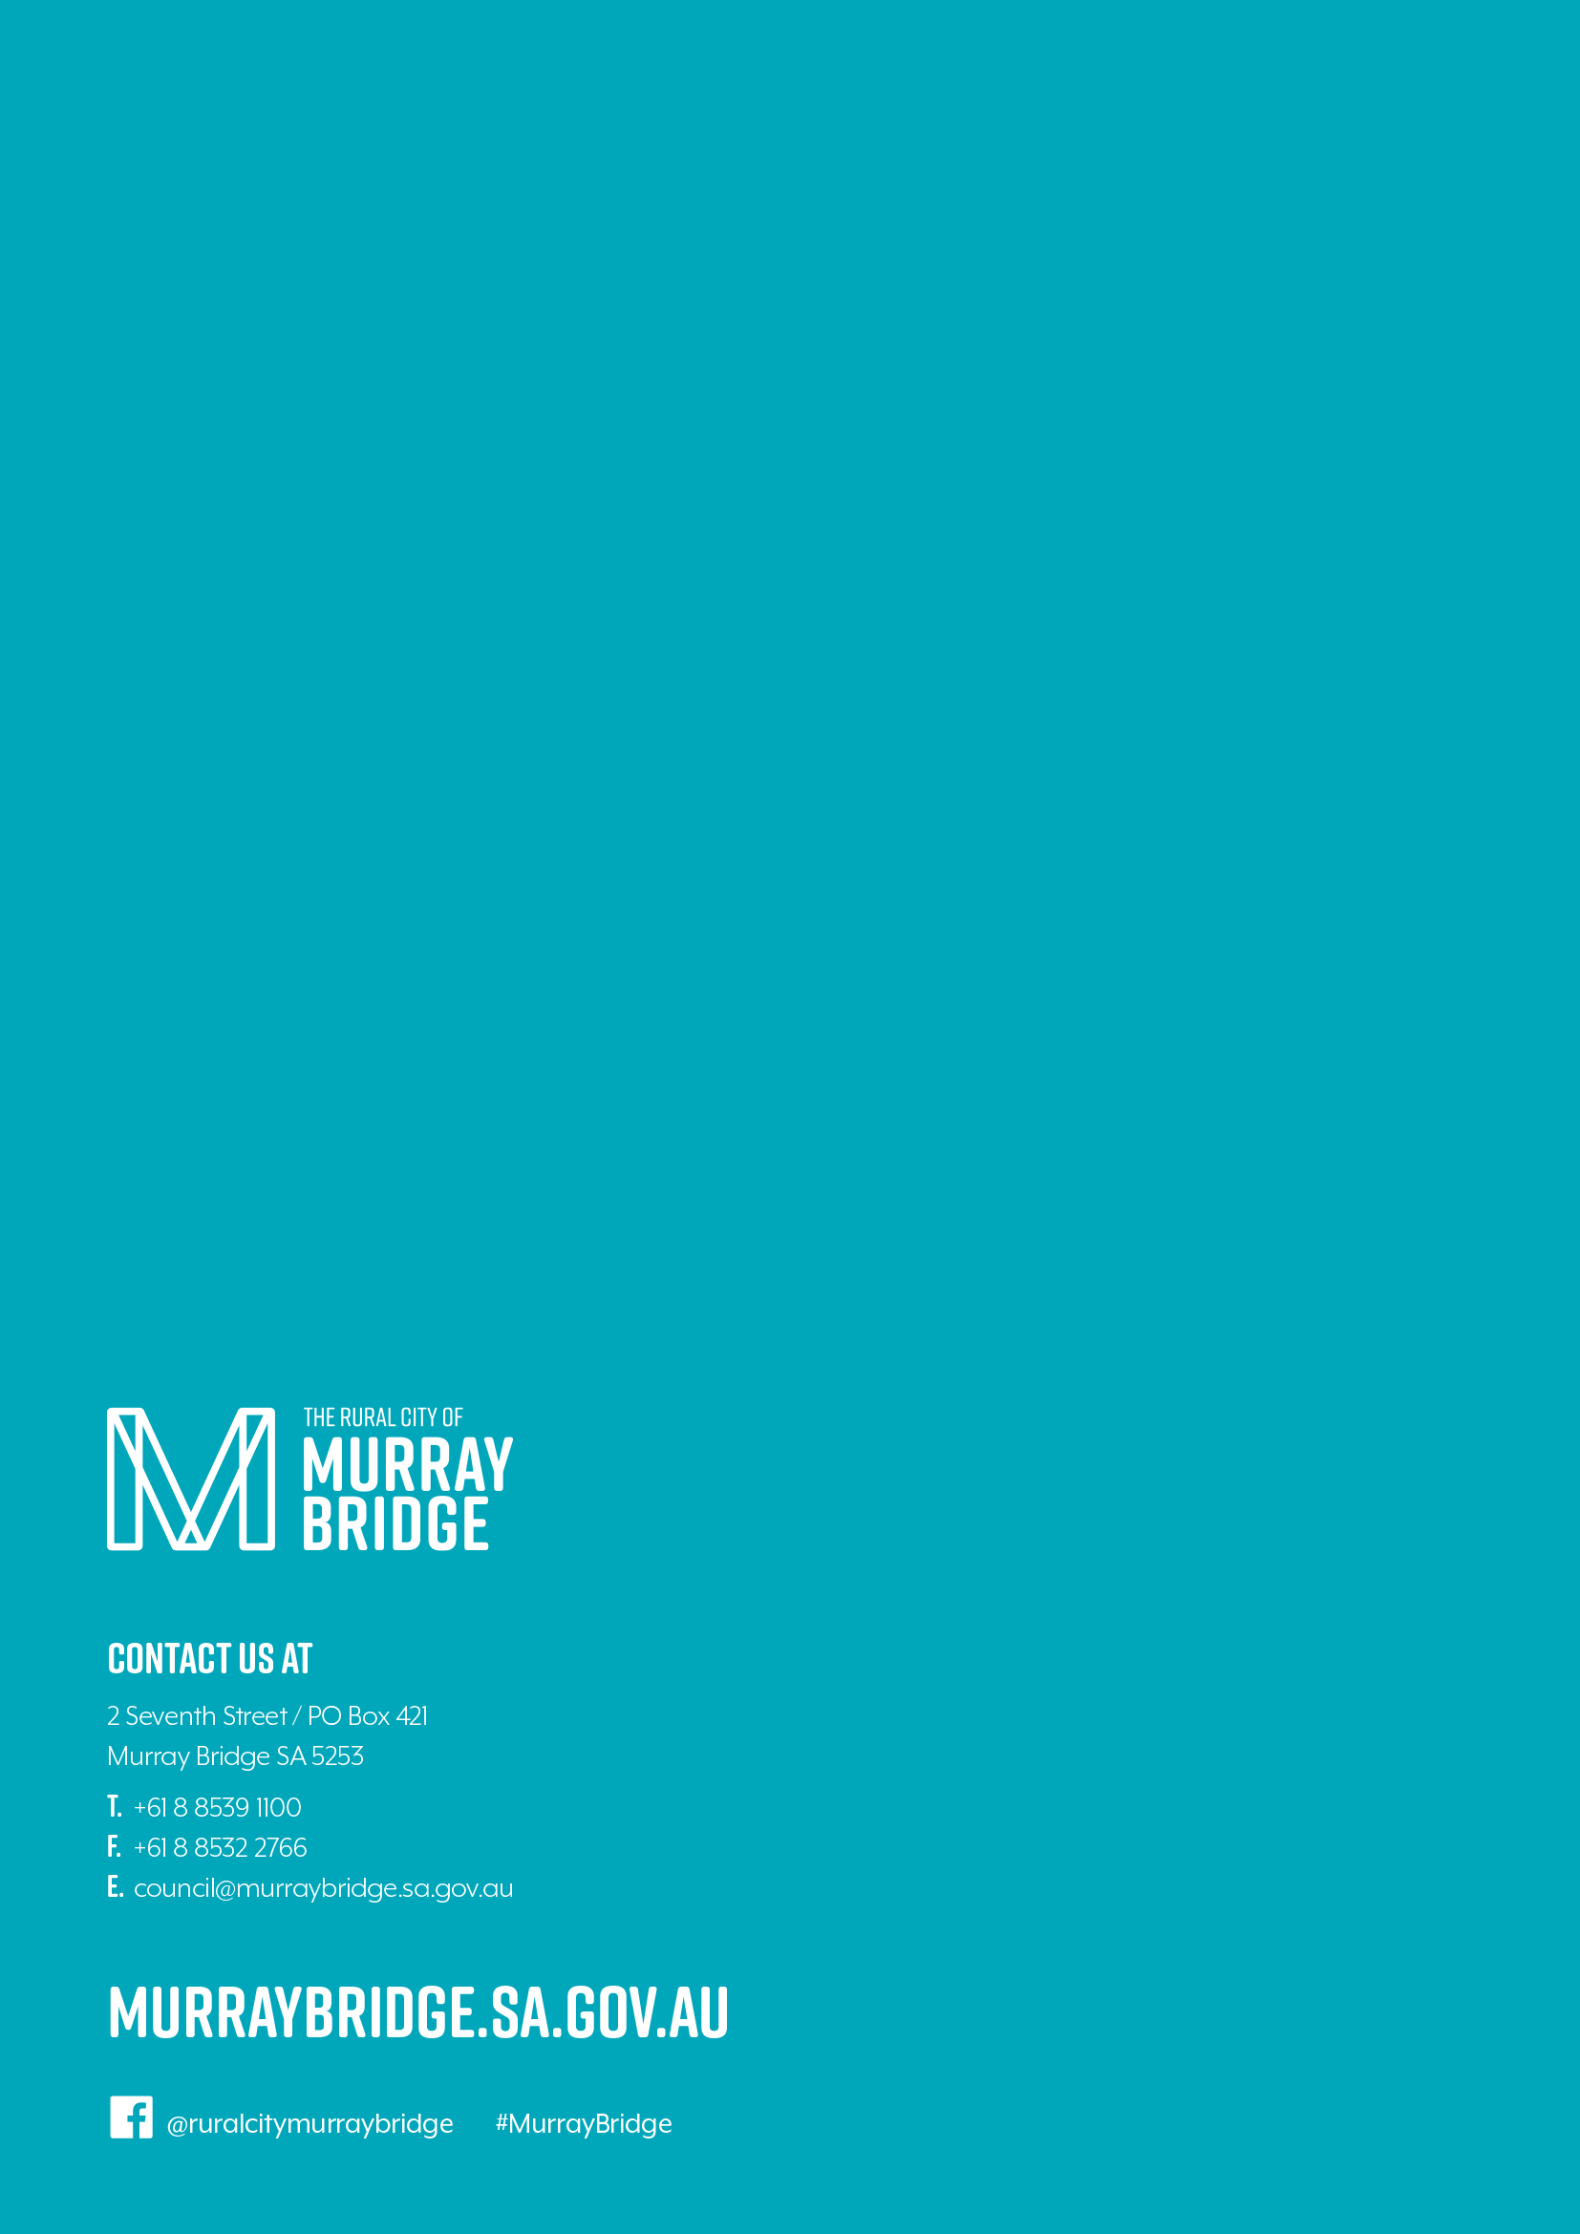

JFA Purple Orange/ Julia Farr Group Language Survey Report 2023 - 20204 https://purpleorange.org.au/application/files/1817/2800/2664/Language_Survey_Report_2024_accessible.pdf
Government of South Australia (2025) Disability Access and Inclusion Plan Guidelines for South Australian state authorities – updated 17 July 2025 DAIP-guidelines.docx
Avery, S. (2018) ‘Culture is Inclusion: A Narrative of Aboriginal and Torres Strait Islander People with Disability’
Australian Bureau of Statistics, Murray Bridge Census All persons QuickStats, 2021, latest release https://www.abs.gov.au/census/find-census-data/quickstats/2021/LGA45040
Regional Public Health and Wellbeing Plan 2022-2026 Murraylands and Riverland Local Government Association https://www.murraybridge.sa.gov.au/__data/assets/pdf_file/0024/1207545/220603-Final_-MR-Health-and-Wellbeing-Plan-2022-2026-1.pdf
REMPLAN Community, 2021 https://login.remplan.com.au/community/
Australian Bureau of Statistics, Murray Bridge Census All persons QuickStats, 2021, latest release https://www.abs.gov.au/census/find-census-data/quickstats/2021/LGA45040
Australian Bureau of Statistics, Murray Bridge Census All persons QuickStats, 2021, latest release https://www.abs.gov.au/census/find-census-data/quickstats/2021/LGA45040
Australian Bureau of Statistics, Murray Bridge Census All persons QuickStats, 2021, latest release https://www.abs.gov.au/census/find-census-data/quickstats/2021/LGA45040
Australian Bureau of Statistics. Disability, Ageing and Carers Australia: Summary of Fin dings. Released 4 Jul 24, https://www.abs.gov.au/statistics/health/disability/disability-ageing-and-carers-australia-summary-findings/2022
Australian Institute of Health and Welfare, National Indigenous Australians Agency, Aboriginal and Torres Strait Islander Health Performance Framework, Measures, 1,14 Disability. Last updated 26 October 2024 https://www.indigenoushpf.gov.au/measures/1-14-disability
Australian Institute of Health and Welfare, Family, domestic and sexual violence. Last updated 28 February 2025 https://www.aihw.gov.au/family-domestic-and-sexual-violence/population-groups/lgbtiqa-people
Australian Bureau of Statistic, Children and young people with disability, 2022. Released 30 Apr 2025 https://www.abs.gov.au/articles/children-and-young-people-disability-2022
Australian Bureau of Statistics. Disability, Ageing and Carers Australia: Summary of Findings. Released 4 Jul 24 https://www.abs.gov.au/statistics/health/disability/disability-ageing-and-carers-australia-summary-findings/latest-release
Australian Institute of Health and Welfare, Australia’s Disability Strategy 2021–2031 Outcomes Framework: 3rd annual report, Economic Participation. Last updated 30 Jan 2025 https://www.aihw.gov.au/reports/australias-disability-strategy/australias-disability-strategy-outcomes-framework/contents/employment-and-financial-security/economic-participation
Royal Commission into Violence, Abuse, Neglect and Exploitation of People with Disability. Final Report – Volume 3, Nature and extent of violence, abuse, neglect and exploitation of people with disability. September 2023 https://disability.royalcommission.gov.au/system/files/2023-09/Finalpercent20Reportpercent20-percent20Volumepercent203percent2Cpercent20Naturepercent20andpercent20Extentpercent20ofpercent20Violencepercent2Cpercent20abusepercent2Cpercent20neglectpercent20andpercent20exploitation.pdf
Australian Institute of Health and Welfare, People with disability in Australia, Social inclusion and community support. Last updated 23 April 2024 People with disability in Australia, Social inclusion and community support - Australian Institute of Health and Welfare
Australian Bureau of Statistics. Disability, Ageing and Carers Australia: Summary of Findings. Released 4 Jul 24, https://www.abs.gov.au/statistics/health/disability/disability-ageing-and-carers-australia-summary-findings/latest-release#carers
Deaf Connect, Auslan user statistics 2021 census. Released 28 June 2022 https://deafconnect.org.au/our-news/auslan-user-statistics-2021-census
Australian Institute of Health and Welfare 2016. Australia’s health 2016. Australia’s health series no. 15. Cat. no. AUS 199. Canberra: AIHW https://www.aihw.gov.au/getmedia/48ee92a8-d373-4354-8df2-d664a974034f/ah16-3-15-vision-hearing-disorders.pdf.aspx
Regional Public Health and Wellbeing Plan 2022-2026, Murraylands and Riverland Local Government Association https://www.murraybridge.sa.gov.au/__data/assets/pdf_file/0024/1207545/220603-Final_-MR-Health-and-Wellbeing-Plan-2022-2026-1.pdf

